<script src="scripts/main.js"></script>

</head>

<body>

    <div id="top"></div>

    <div id="header">

        <img src="img1/istockphoto-135898272-1024x1024.jpg" alt="Mr green fish emporium">

        <h1>Welcome to msy smelly fish shop</h1>

        <p>We sell the smelliest fish on the planet</p>

    </div>

    <hr>

    <div id="navigation">

        <ul>

            <li><a onclick="alert('Yo ninja, welcome to my website!');" style="color:red;"href="contact.html">Contact us</a></li>

            <li><a href="prices/freshwater-fish-prices.html">Price list</a></li>

            <li><a href="http://www.thenetninja.co.uk" target="blank">Try out some awsome more webtutorials</a></li>

            <li><a href="downloads/abc.pdf">Download our full price list</a></li>

        </ul>

    </div>

    <hr>

alert("Yo ninja, welcome to my website!");

wpierw załaduje skrypt a potem stronę. Gdy kliknie się Contact us wyświetli komunikat

var myAge = 28;

if(myAge > 30){

    document.write("you are over 30")

}else if( myAge >20){

    document.write("you are over 20")

}

else if( myAge >10){

    document.write("you are over 10")

}

else {

    document.write("you are not over 10")

}

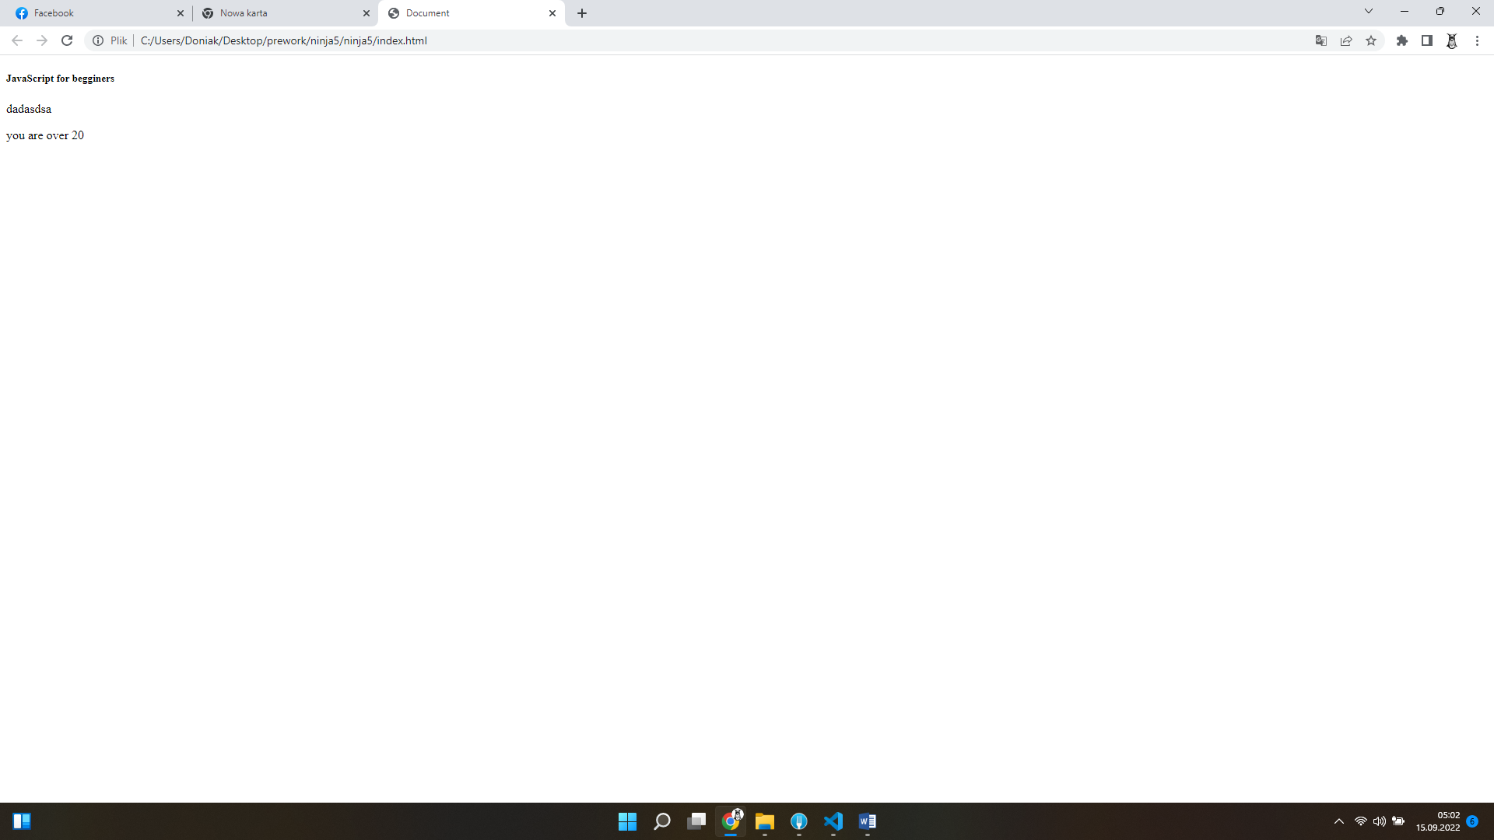

var myAge = 28;

if(myAge<19 || myAge >30){

document.write("you aint coming!");

}

else

{

    document.write("You can come, you cool dude");

}

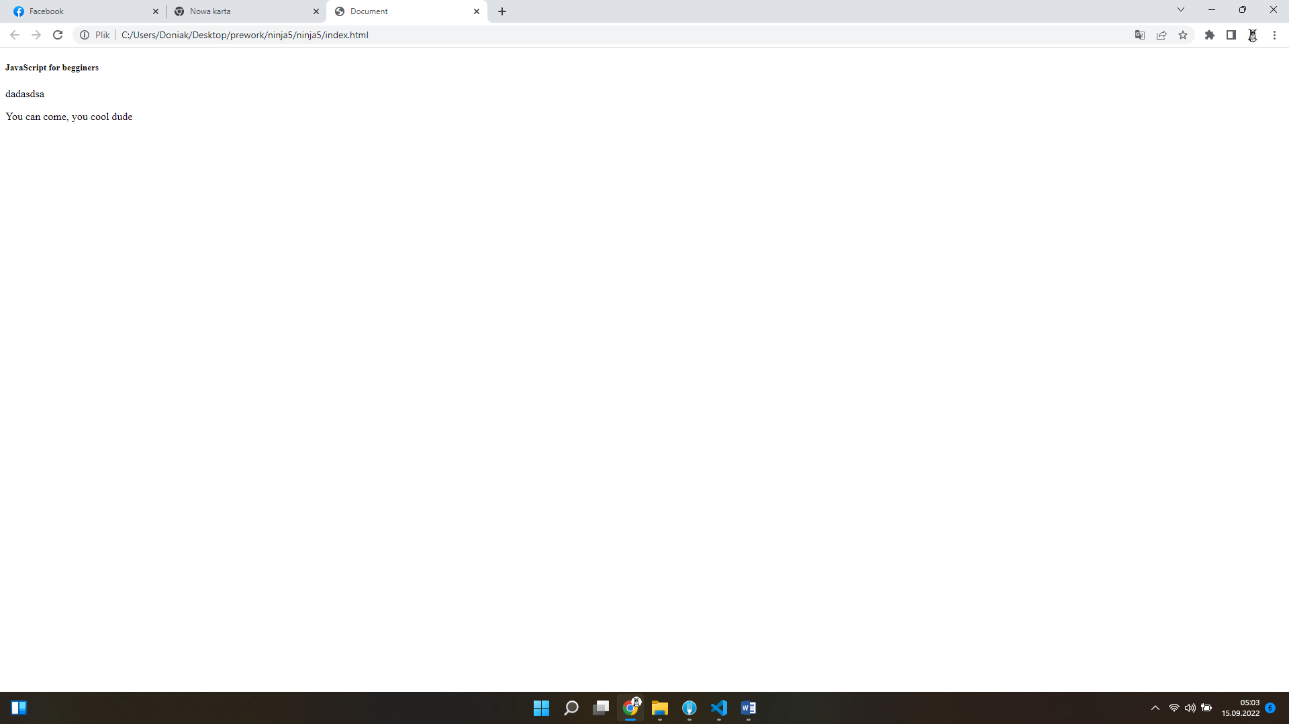

var myAge = 28;

while(myAge<40){

document.write("your age is less than 10");

document.write("<br>");

myAge++;

}

document.write("you are now over 40")

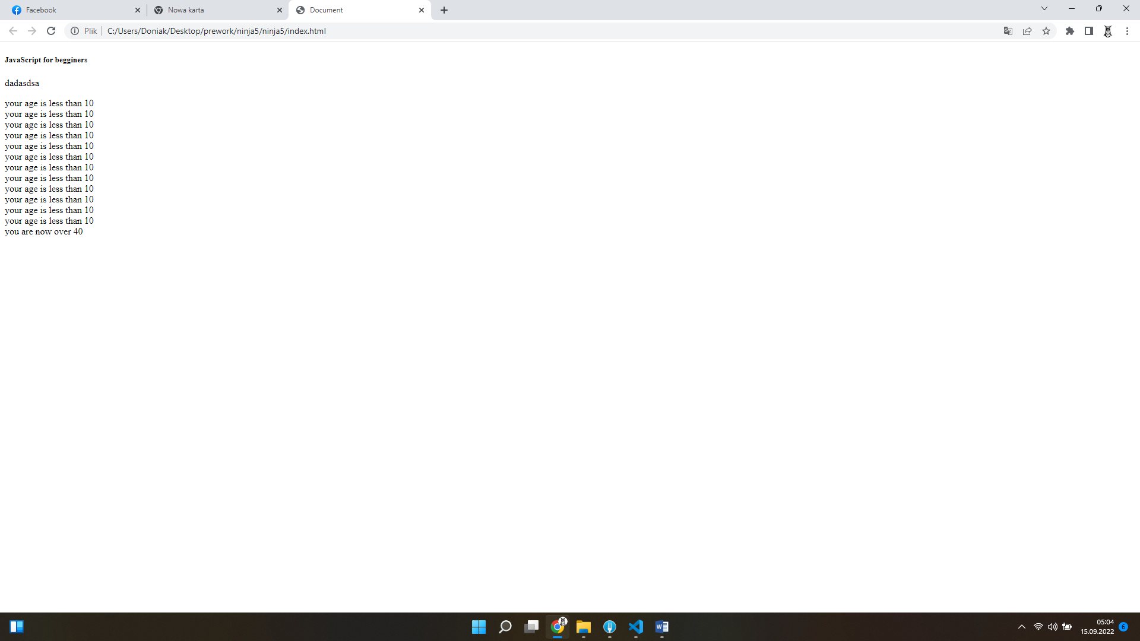

var links= document.getElementsByTagName("a");

for (i=0; i<links.length; i++) {

    console.log("this is link numer " + i);

}

document.write("all links now looped");

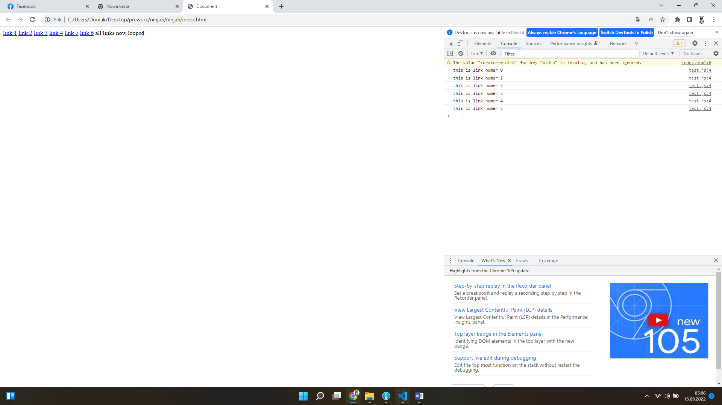

for (i=0; i < 10; i++){

    if( i=== 5 || i === 3){

        continue;

    }

    console.log(i);

    if(i===7){

        break;

    }

}

console.log("I have broken out of the loop");

The strict equality operator (===) checks whether its two operands are equal, returning a Boolean result. Unlike the [equality](https://developer.mozilla.org/en-US/docs/Web/JavaScript/Reference/Operators/Equality) operator, the strict equality operator always considers operands of different types to be different.

console.log(1 === 1);

// expected output: true

console.log('hello' === 'hello');

// expected output: true

console.log('1' === 1);

// expected output: false

console.log(0 === false);

// expected output: false

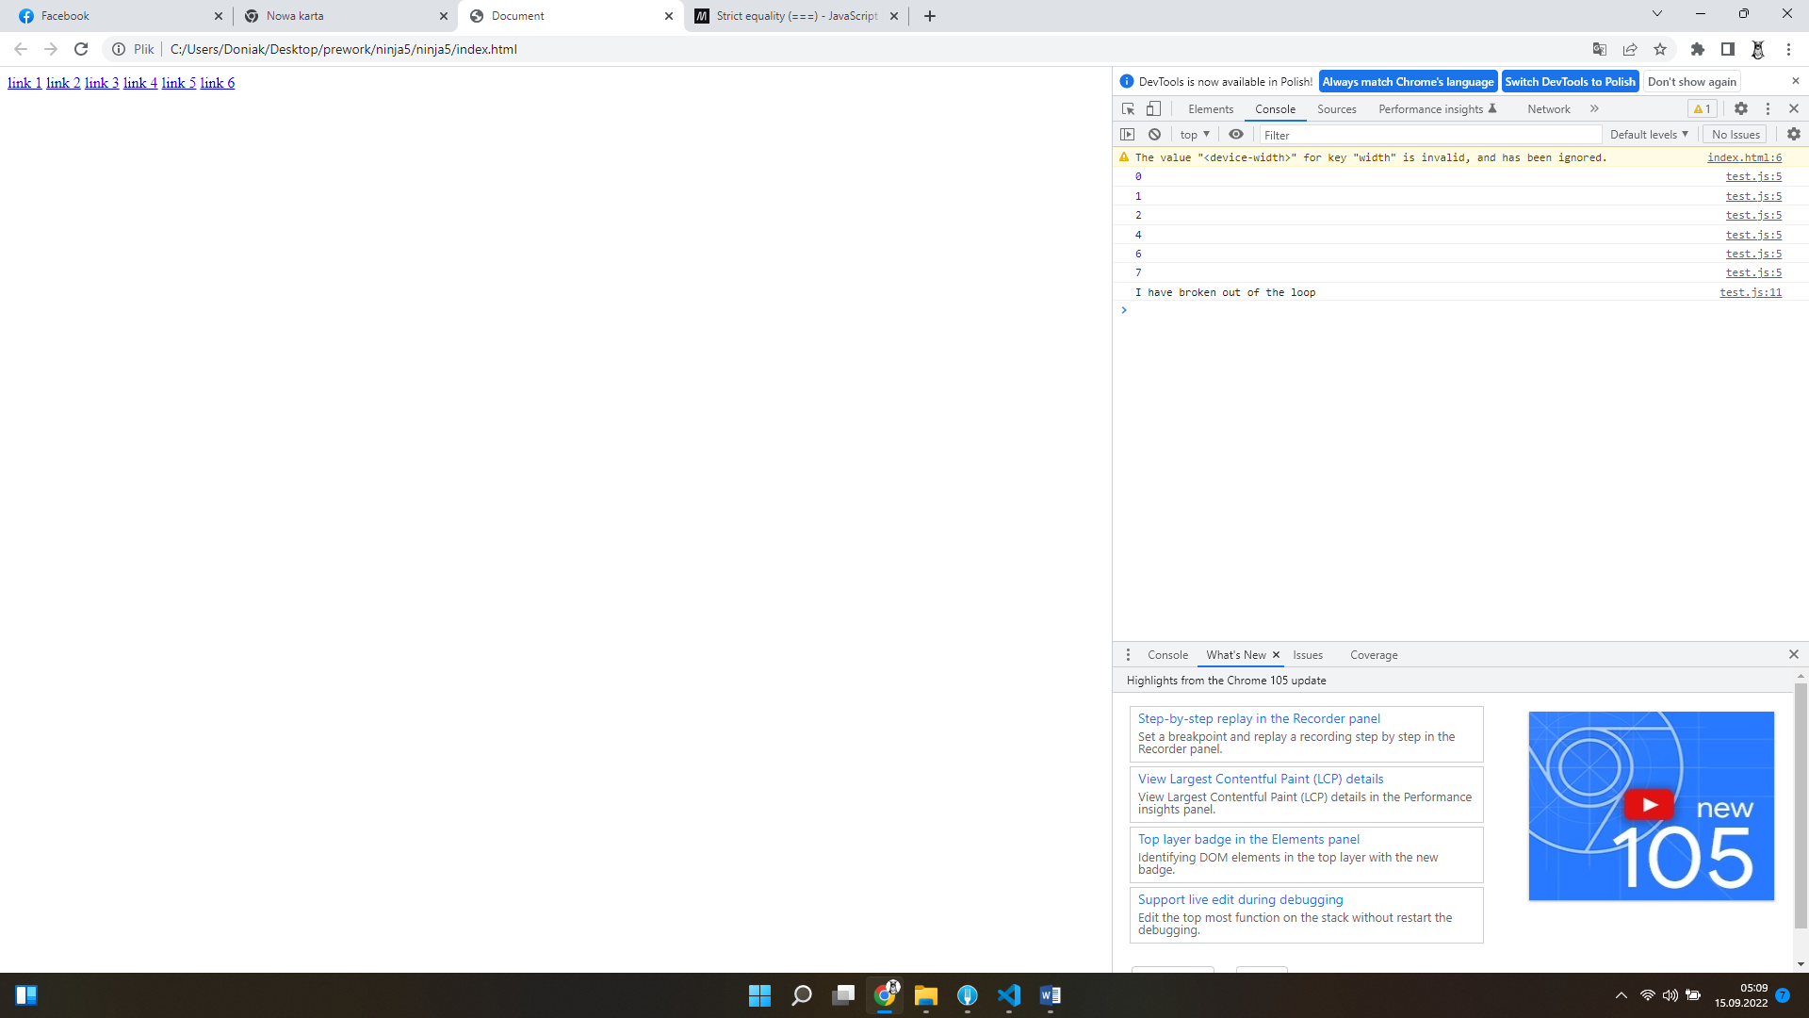

\*\*\*\*\*\*\*\*\*\*\*\*\*\*\*\*\*\*\*\*\*\*\*\*\*\*\*\*\*\*\*\*\*\*\*\*\*\*\*\*\*\*\*\*\*\*\*\*\*\*\*\*\*\*\*\*  
var links = document.getElementsByTagName("a");

for(i=0; i<links.length; i++){

    links[i].className = "link-" + i;

}

<body>

    <a href="#">link </a>

    <a href="#">link </a>

    <a href="#">link </a>

    <a href="#">link </a>

    <a href="#">link </a>

    <a href="#">link </a>

    <script src="test.js"></script>

</body>

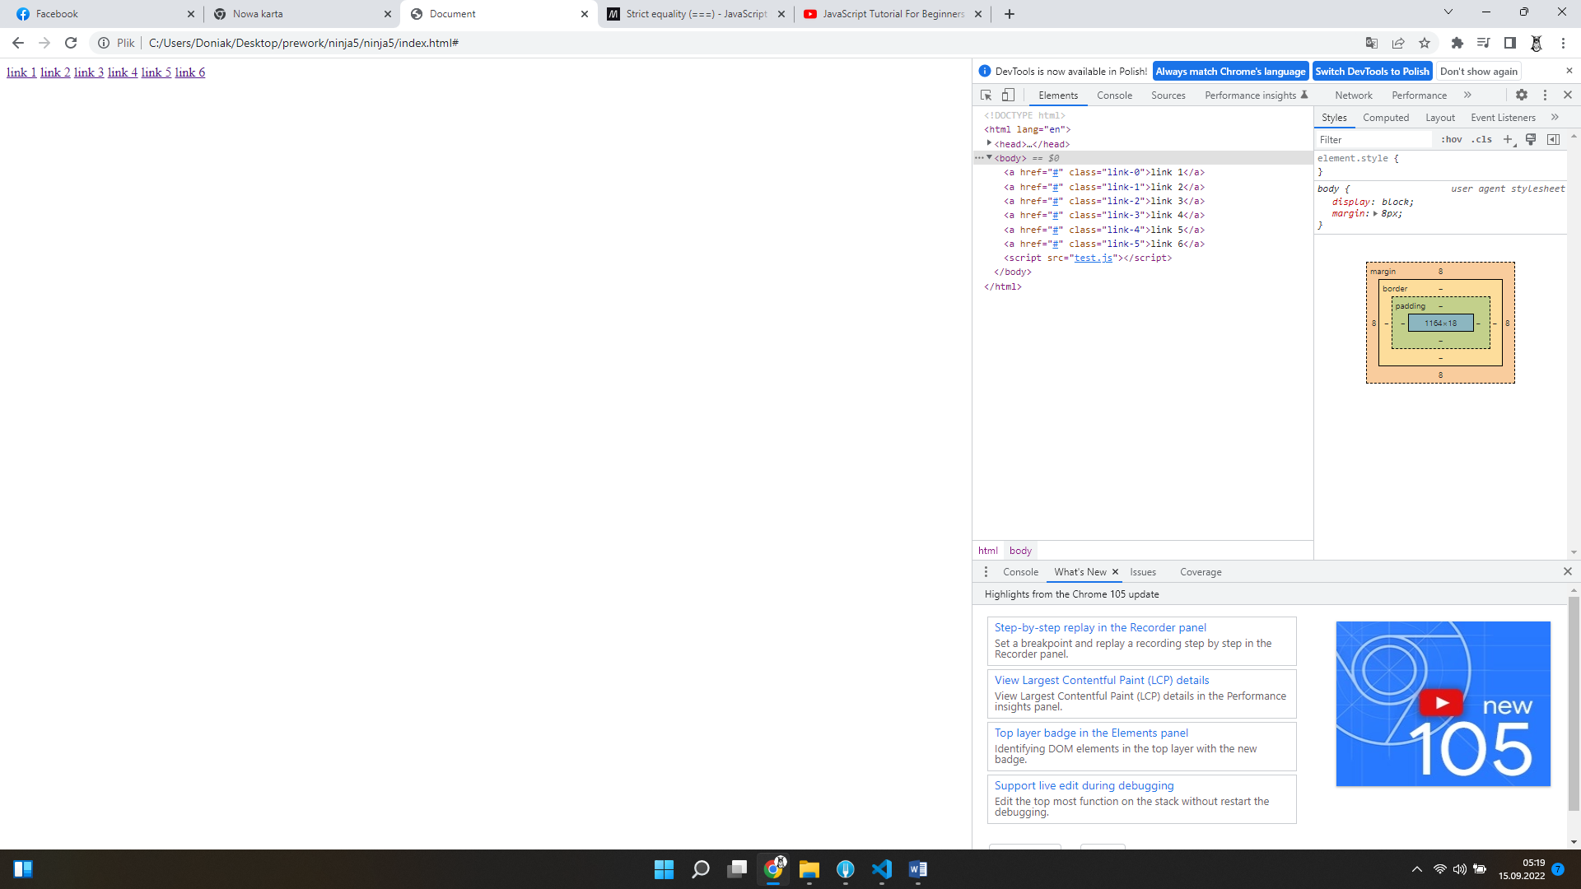

function getAvarage(a,b){

    var average=(a+b)/2;

    return average;

}

console.log(getAvarage(2,3) + " my result");

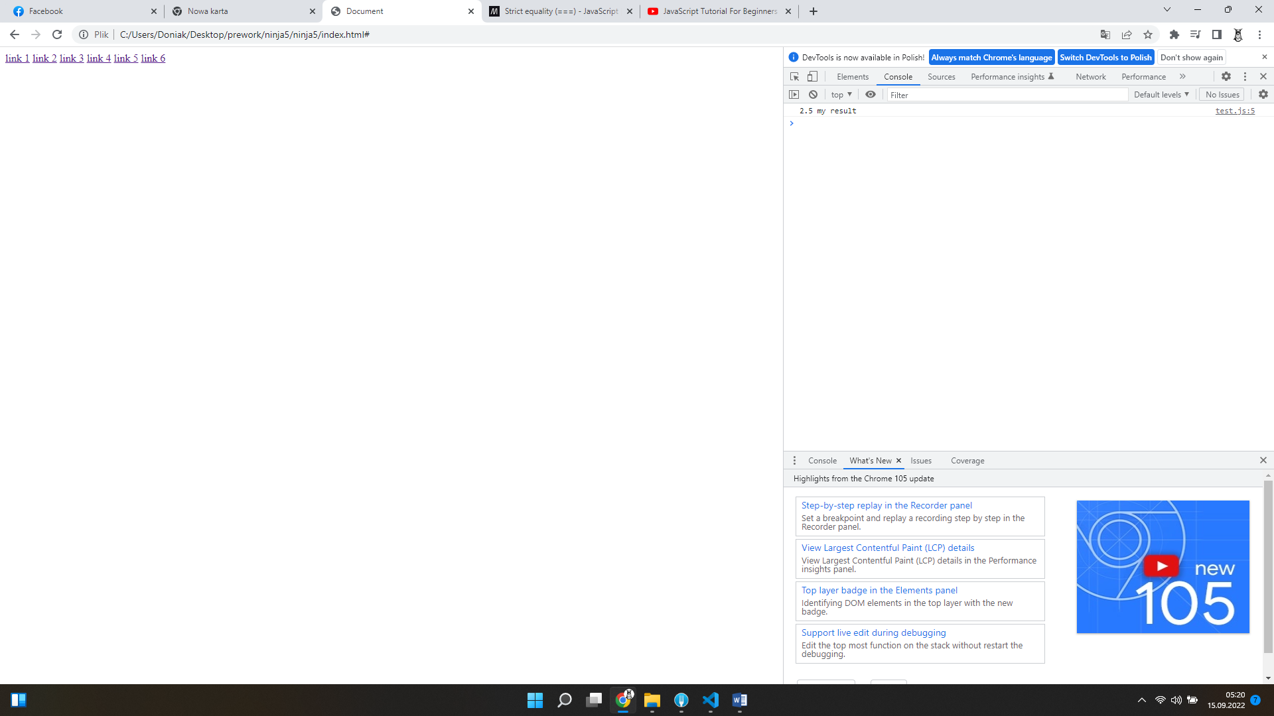

function getAvarage(a,b){

    var average=(a+b)/2; //zmienna lokalna

    return average;

}

var myResult = getAvarage(2,3); // zmienna globalna

function logResult(){

console.log(myResult + " my result");

}

logResult();

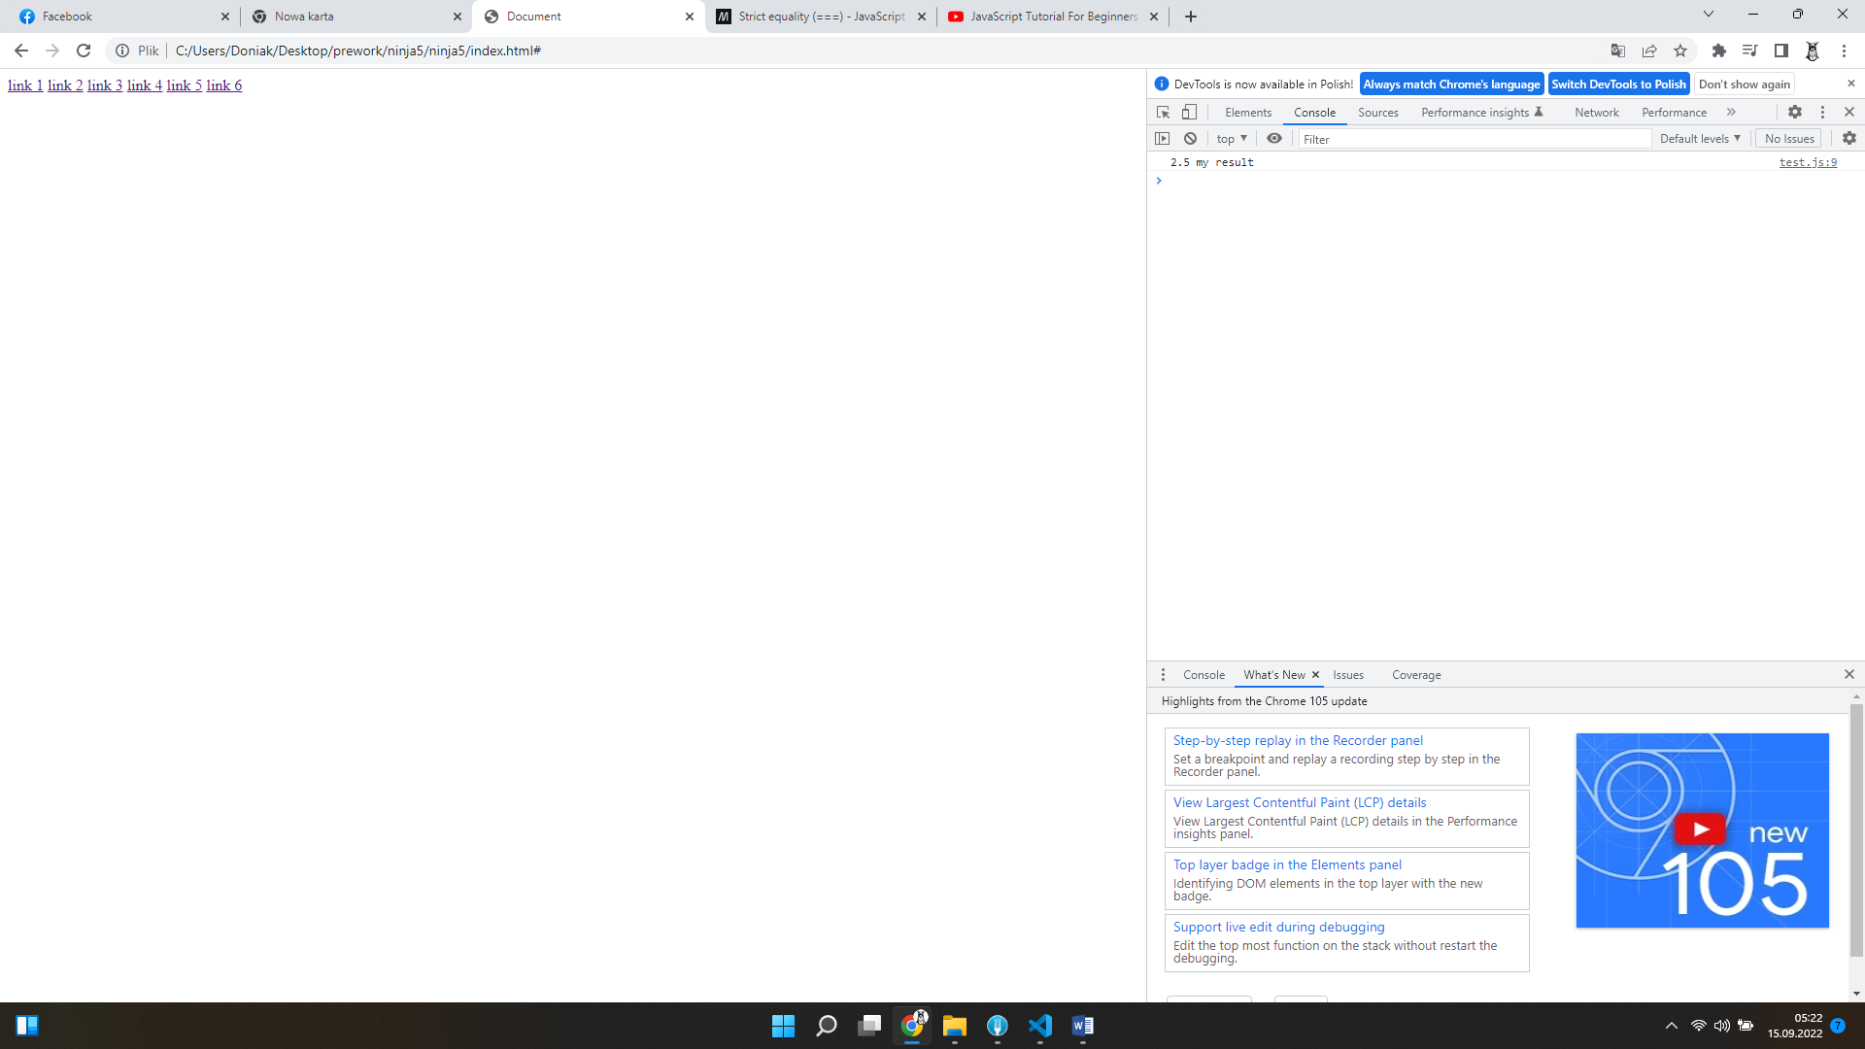

var a ="apple";

var b = 4;

if(isNaN(a)){

    console.log("that aint even a number");

}

else{

    console.log("meaning of life is" + (a\*b));

}

The **isNaN()** function determines whether a value is [NaN](https://developer.mozilla.org/en-US/docs/Web/JavaScript/Reference/Global_Objects/NaN) or not. Because coercion inside the isNaN function can be [surprising](https://developer.mozilla.org/en-US/docs/Web/JavaScript/Reference/Global_Objects/isNaN" \l "confusing_special-case_behavior), you may alternatively want to use [Number.isNaN()](https://developer.mozilla.org/en-US/docs/Web/JavaScript/Reference/Global_Objects/Number/isNaN).

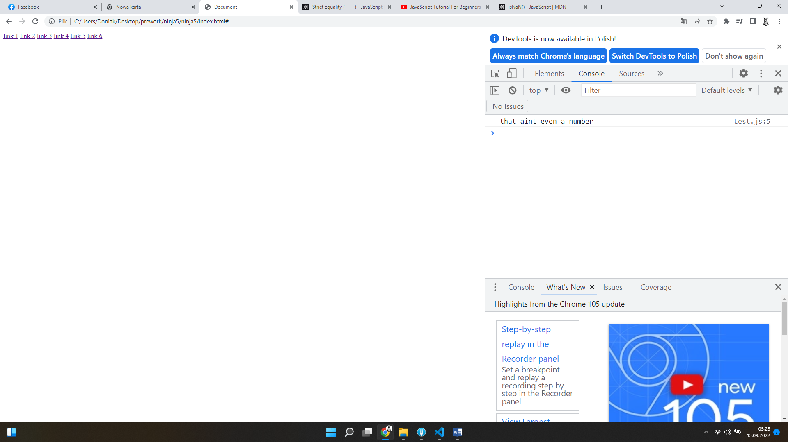

var str = "hello, world";

var str2 = str.slice(2,9);

var str3 = str.slice(2);

var tags ="meat, ham, salami, prok, beef, chicken";

var tagsArray = tags.split(",");

document.write(str);

document.write(str2);

document.write(str3);

document.write(tags);

document.write(tagsArray);

console.log(str);

console.log(str2);

console.log(str3);

console.log(tags);

console.log(tagsArray);

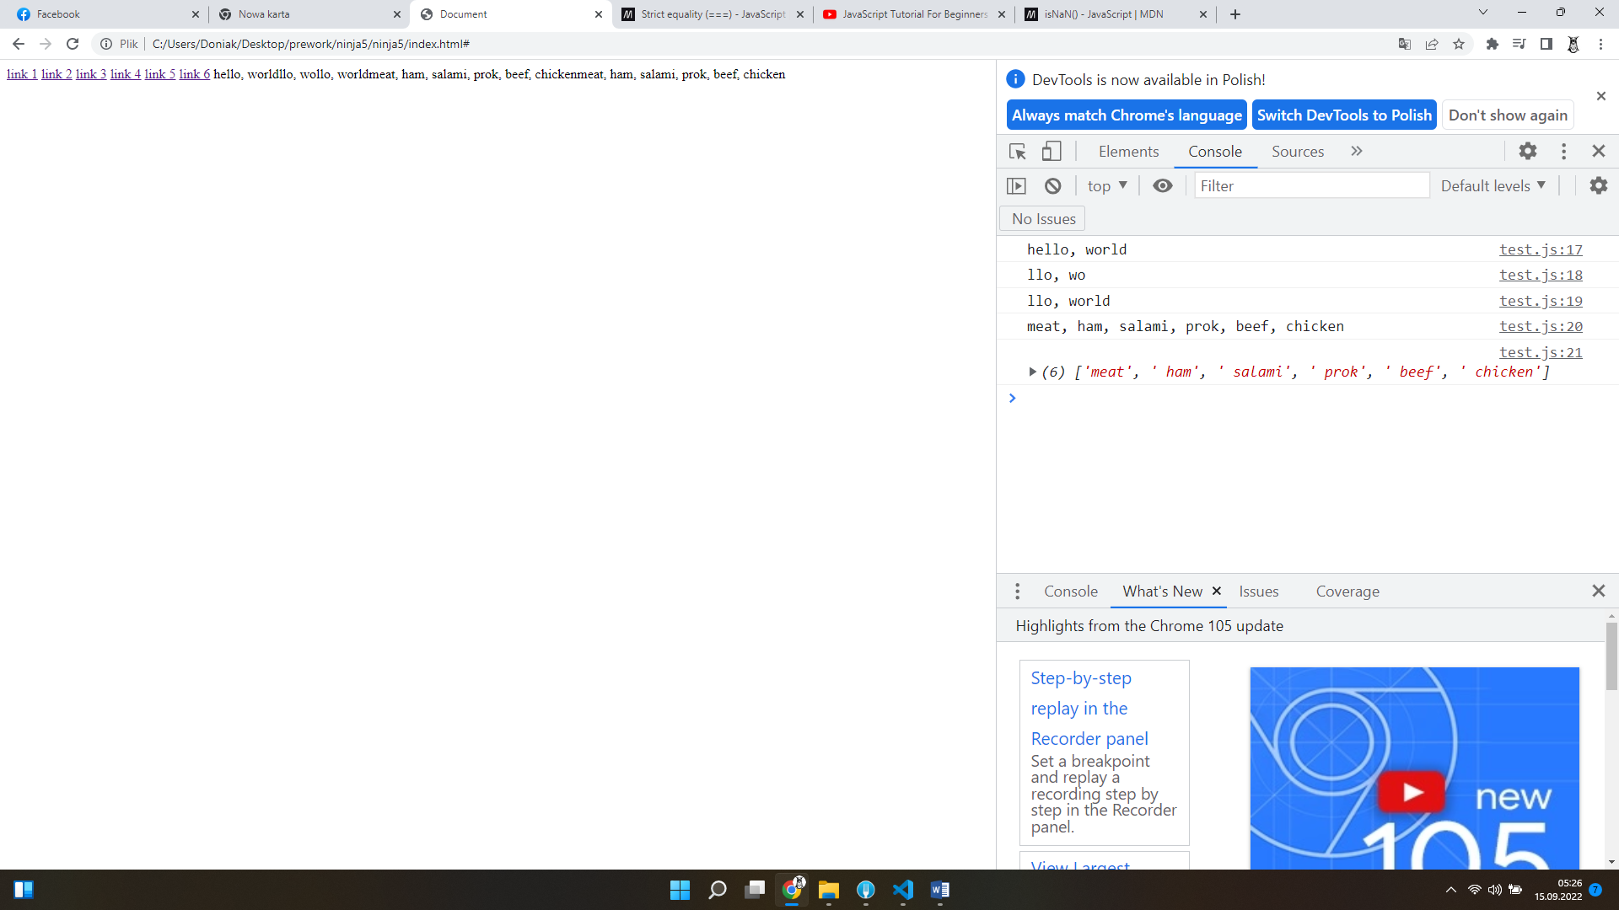

var myArray = new Array();

myArray[0]=8;

myArray[1]="hello";

var myCar= new Object();

myCar.maxSpeed=50;

myCar.driver="Arek"

myCar.drive= function() {

    console.log("now driving");};

myCar.drive();

var myCar2 ={

    maxSpeed:20,

    driver:"Arek2",

    drive:function(speed, time){

    console.log(speed\*time + " km path");}

    };

    console.log(myCar2.maxSpeed);

    myCar2.drive(10, 2);

OBJECT

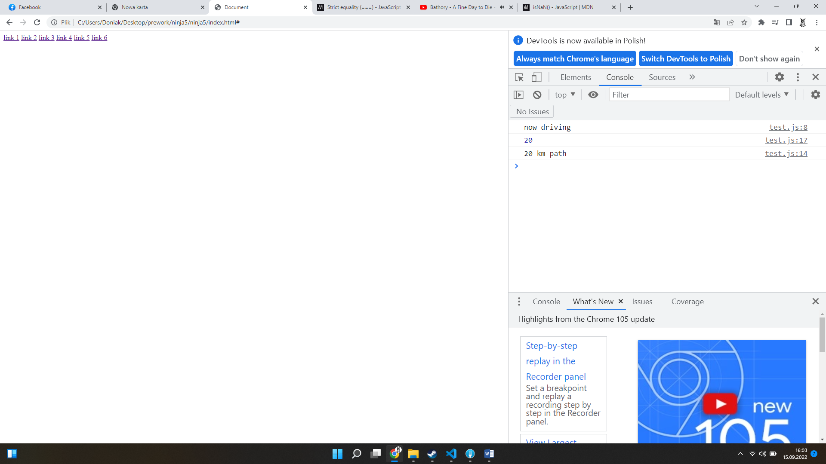

var myArray = new Array();

myArray[0]=8;

myArray[1]="hello";

var myCar= new Object();

myCar.maxSpeed=50;

myCar.driver="Arek"

myCar.drive= function() {

    console.log("now driving");};

myCar.drive();

var myCar2 ={

    maxSpeed:20,

    driver:"Arek2",

    drive:function(speed, time){

    console.log(speed\*time + " km path");},

    test:function(){

        console.log(this);

    }

    };

    var myCar3 ={

        maxSpeed:20,

        driver:"Arek3",

        drive:function(speed, time){

        console.log(speed\*time + " km path");},

        test:function(){

            console.log(this);

        },

        logDriver:function(){

            console.log("driver name is " +this.driver);

        }

        };

    myCar2.test();

    myCar3.test();

    console.log(myCar2.maxSpeed);

    myCar2.drive(10, 2);

    myCar3.logDriver();

THIS

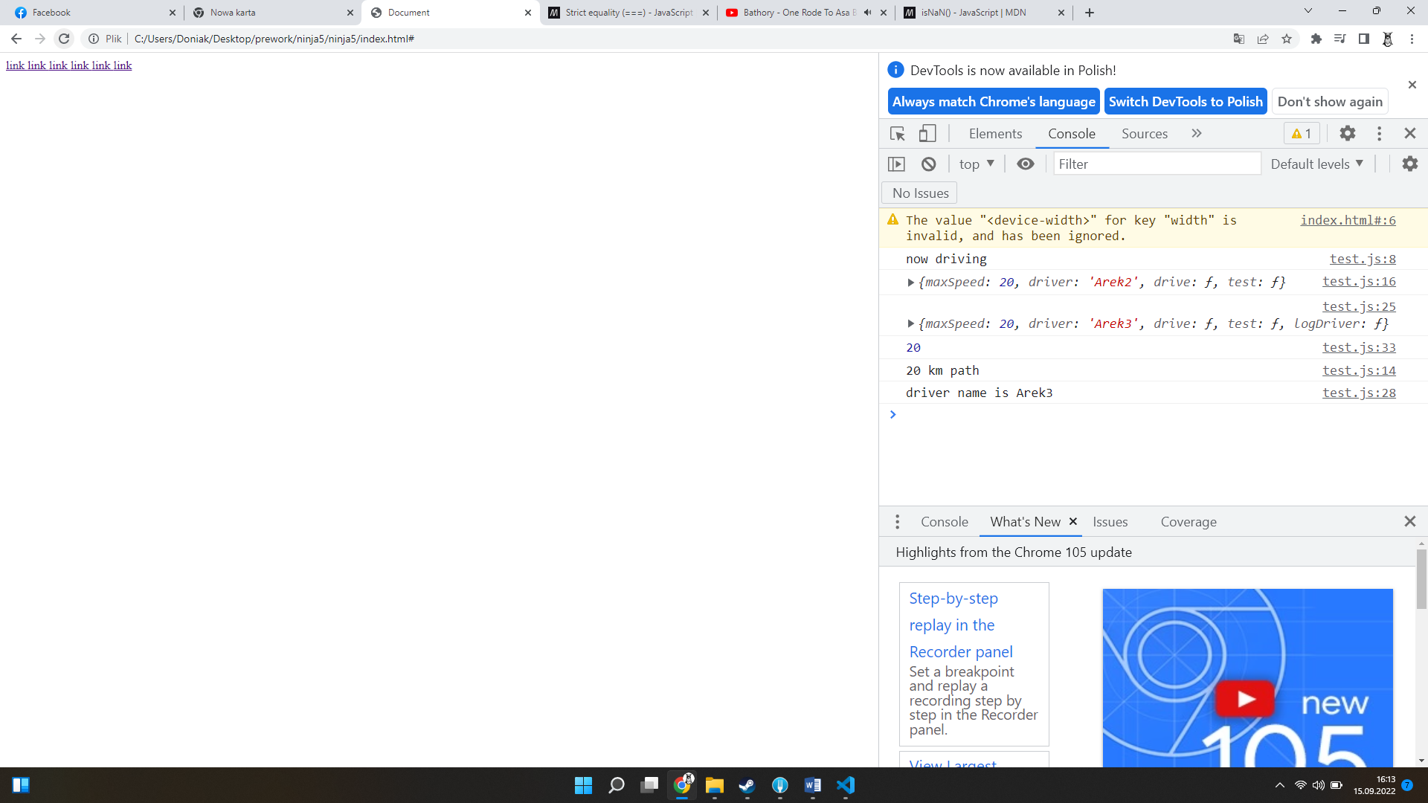

var Car = function(maxSpeed, driver){

    this.maxSpeed = maxSpeed;

    this.driver = driver;

    this.drive = function(speed, time){

        console.log(speed\*time);

    };

    this.logDriver = function(){

        console.log("driver name is " + this.driver);

    };

}

var myCar = new Car(70, "dudi");

var myCar2 = new Car(20, "donia");

var myCar3 = new Car(30, "pitek");

var myCar4 = new Car(40, "raf");

myCar.drive(30,5);

myCar3.logDriver();

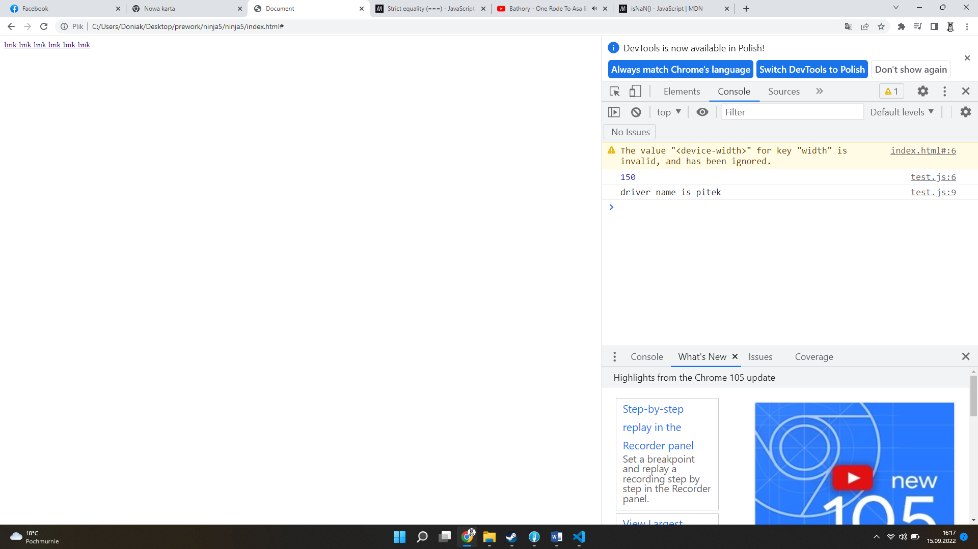

var urodziny = new Date(1994, 7, 10, 23, 15, 23);

var urodziny2 = new Date(1994, 7, 10, 23, 15, 23);

//get the mont of the date (0-11)

console.log(urodziny.getMonth());

//get the full year (YYYY)

console.log(urodziny.getFullYear());

//get the date of the month (1-31)

console.log(urodziny.getDate());

// get the day of the week(0-6)

console.log(urodziny.getDay());

//get the hour of the date(0-23)

console.log(urodziny.getHours());

//get the number of millisecond since

console.log(urodziny.getTime());

if(urodziny.getTime() == urodziny2.getTime()){

    console.log("birthdays are equal");

} else {

    console.log("birthdays are not equal");

}

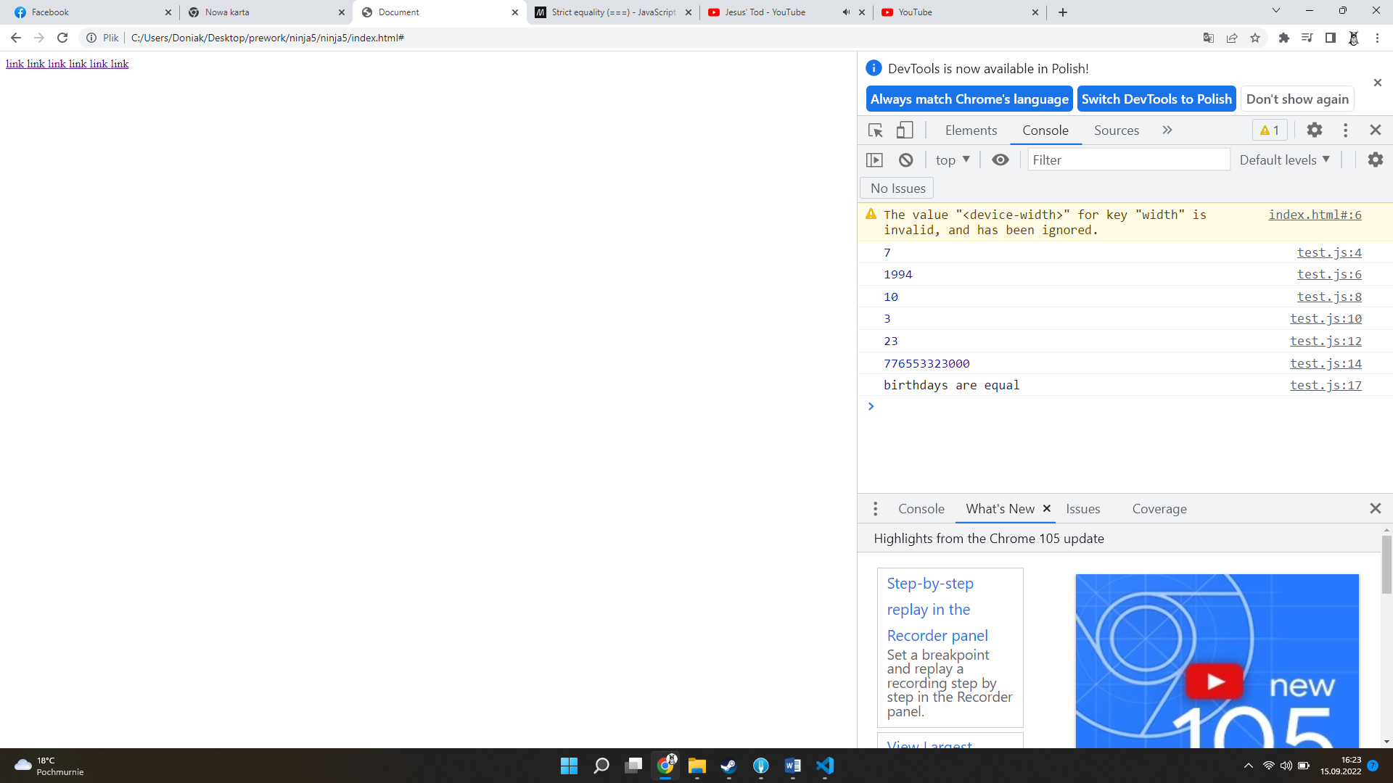

var myContentDivs = document.getElementsByClassName("content");

console.log(

    myContentDivs,

    myContentDivs[1].getElementsByTagName("a")

);

var myA = myContentDivs[1].getElementsByTagName("a");

myA[0].innerHTML="asdasda";

<body>

    <div class="content">

        <a href="#">link </a>

        <a href="#">link </a>

        <a href="#">link </a>

        <a href="#">link </a>

        <a href="#">link </a>

        <a href="#">link </a>

    </div>

    <div class="content">

        <a href="#">link </a>

        <a href="#">link </a>

        <a href="#">link </a>

        <a href="#">link </a>

        <a href="#">link </a>

        <a href="#">link </a>

    </div>

    <script src="test.js"></script>

</body>

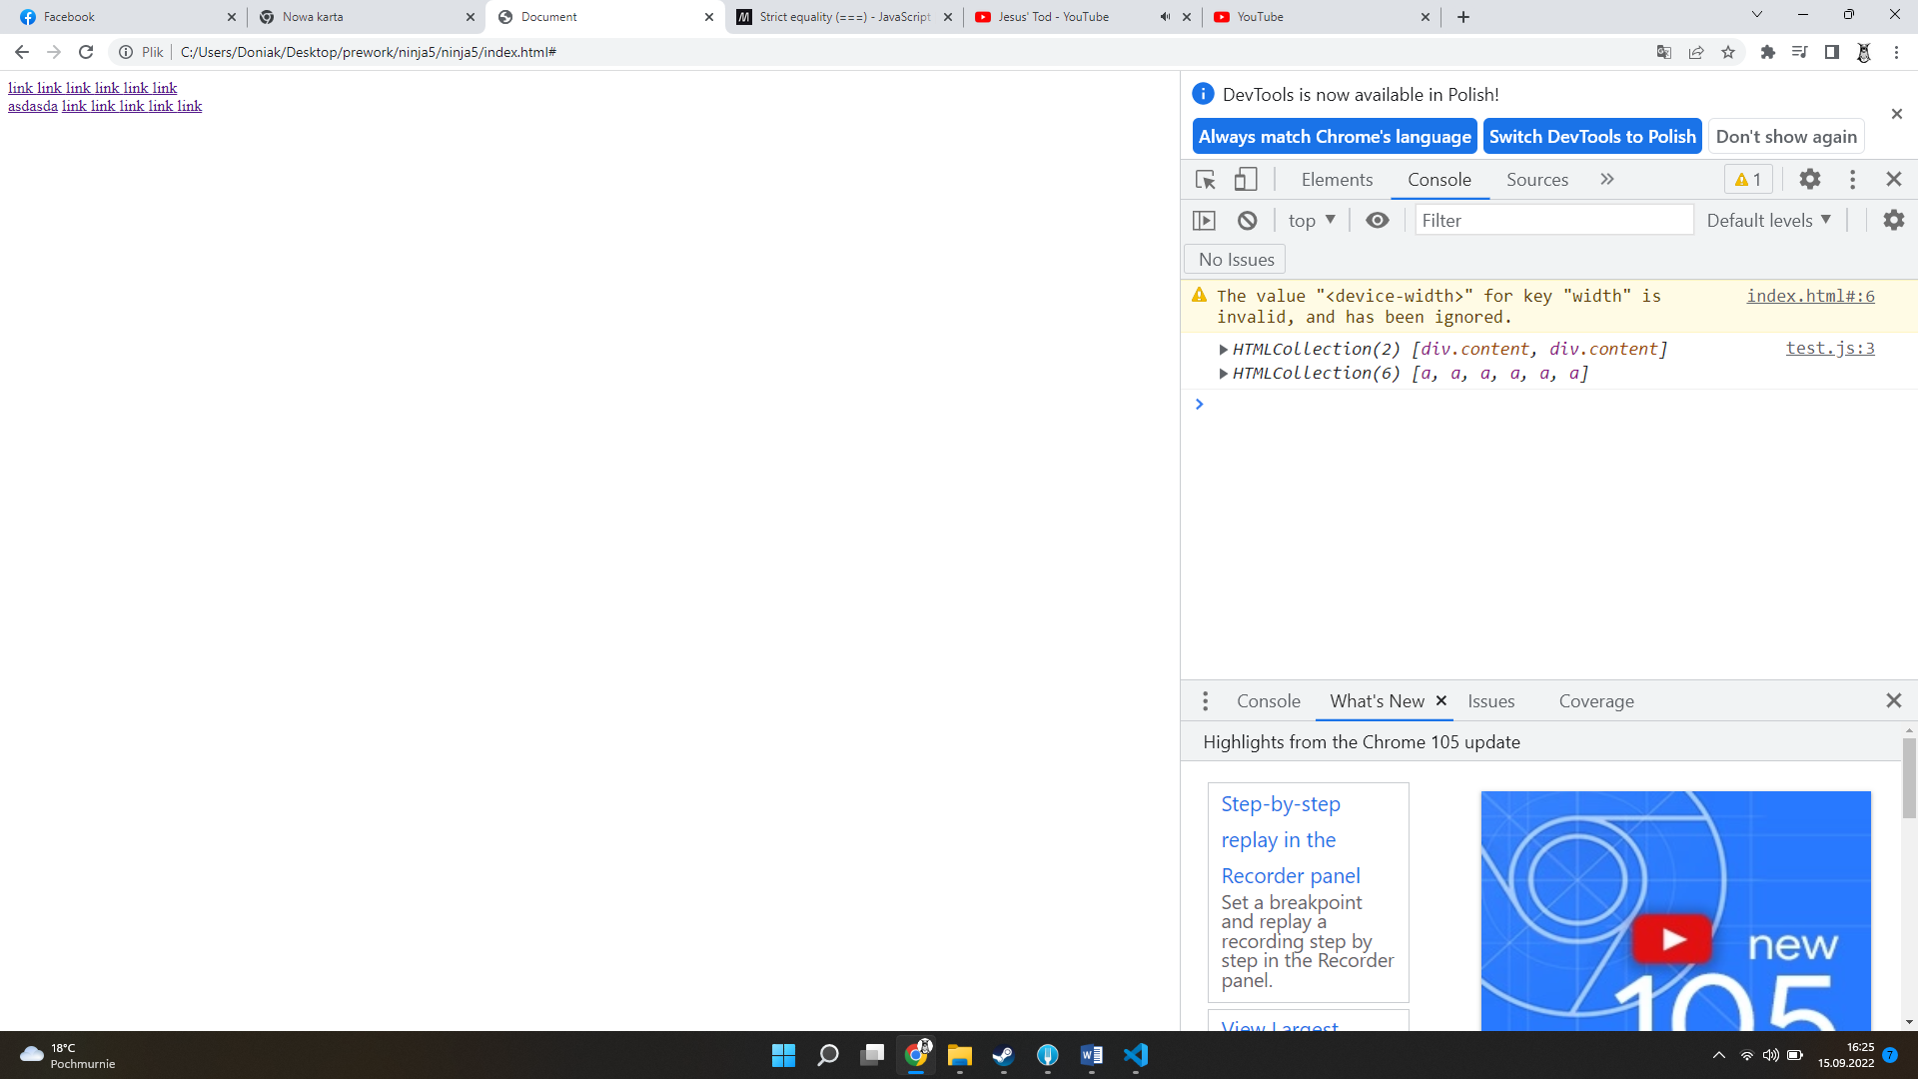

Pobranie elementu przez klasę i podmiana tekstu

var myBody = document.getElementsByTagName("body");

console.log(myBody,

    myBody[0].innerHTML

    );

//myBody[0].innerHTML = "<p> I am a paragraph tag</p>";

myPrice= document.getElementsByClassName("price");

myPrice[0].innerHTML = "<span> 0.99</span>";

  <section id="shop">

                <img class="product-image" src="images/bike.jpg" alt="RetroSyperb image">

                <h2 class="product-name">Bicycle RetroSyperb Vii #1</h2>

                <span class="price">299.99$</span>

                <a class="add-to-bag" href="#">Add to shopping basket</a>

                <img class="rating" src="images/stars.png" alt="star-rating">

            </section>

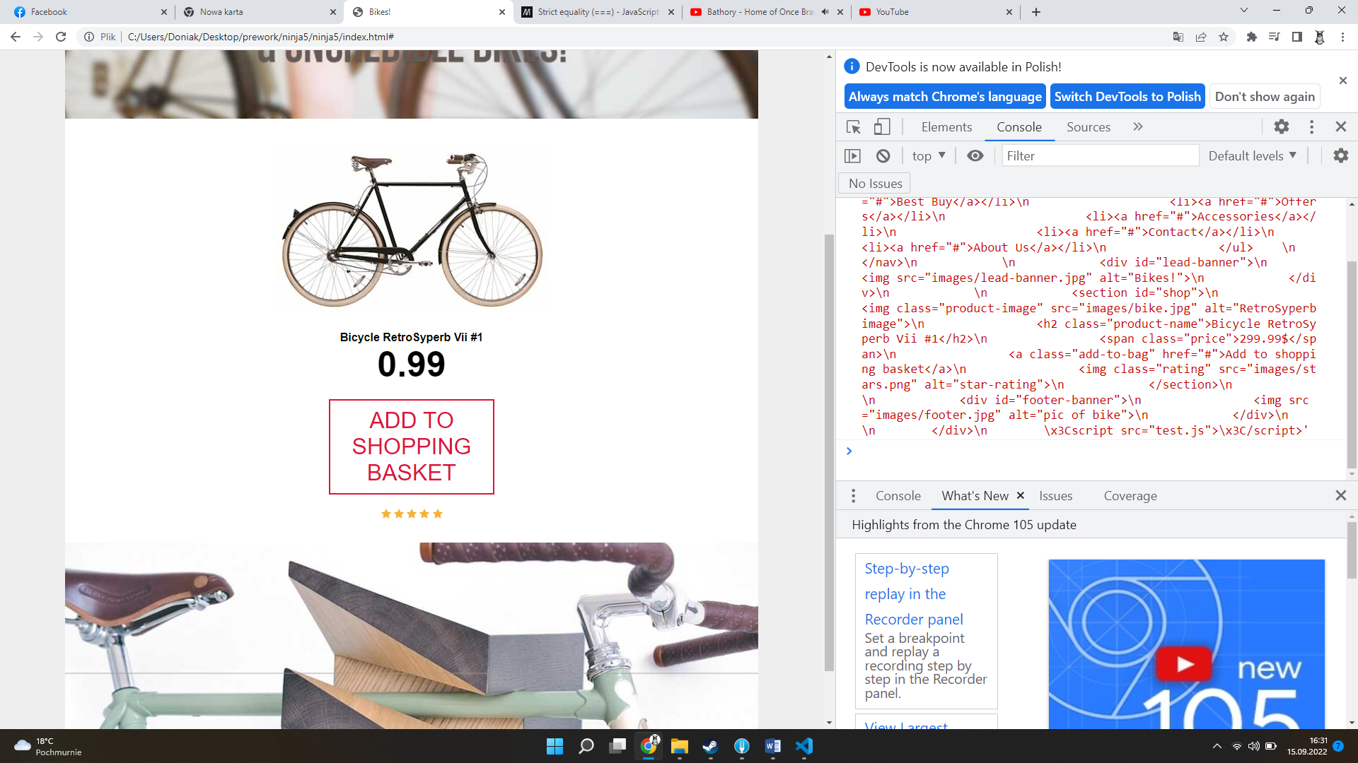

Podmiana tekstu

\*\*\*\*\*\*\*\*\*\*\*\*\*\*\*\*\*\*\*\*\*\*\*\*\*\*\*\*\*\*\*\*

var myBody = document.getElementsByTagName("body");

console.log(myBody,

    myBody[0].innerHTML

    );

//myBody[0].innerHTML = "<p> I am a paragraph tag</p>";

myPrice= document.getElementsByClassName("price");

myPrice[0].innerHTML = "<span> 0.99</span>";

myMainNav=document.getElementById("main-navigation");

console.log(myMainNav.getAttribute("class"));

myMainNav.setAttribute("class", "pie");

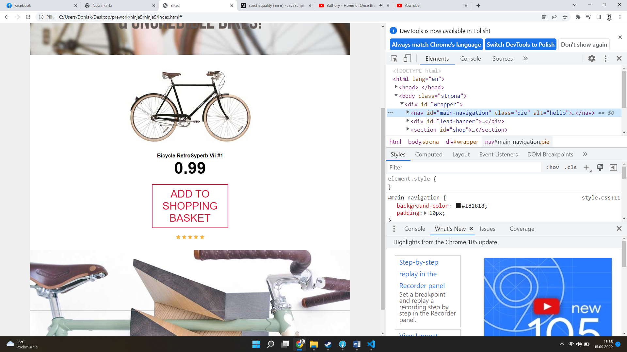

myMainNav=document.getElementById("main-navigation");

console.log(myMainNav.getAttribute("class"));

myMainNav.setAttribute("class", "pie");

// przykład 1

myMainNav.setAttribute("style", "position: relative;" );

myMainNav.setAttribute("style", "background-color: red;" );

//przykład 2

var newLi = document.createElement("li");

var menu =document.getElementById("main-navigation").getElementsByTagName("ul")[0];

//menu.appendChild(newLi);

menu.insertBefore(newLi, menu.getElementsByTagName("li")[0]);

var newA = document.createElement("a");

newLi.appendChild(newA);

newA.innerHTML = "BLOG";

            <nav id="main-navigation" class="nav" alt="hello">

                <ul>

                    <li><a href="#" class="current">Bikes</a></li>

                    <li><a href="#">Best Buy</a></li>

                    <li><a href="#">Offers</a></li>

                    <li><a href="#">Accessories</a></li>

                    <li><a href="#">Contact</a></li>

                    <li><a href="#">About Us</a></li>

                </ul>

            </nav>

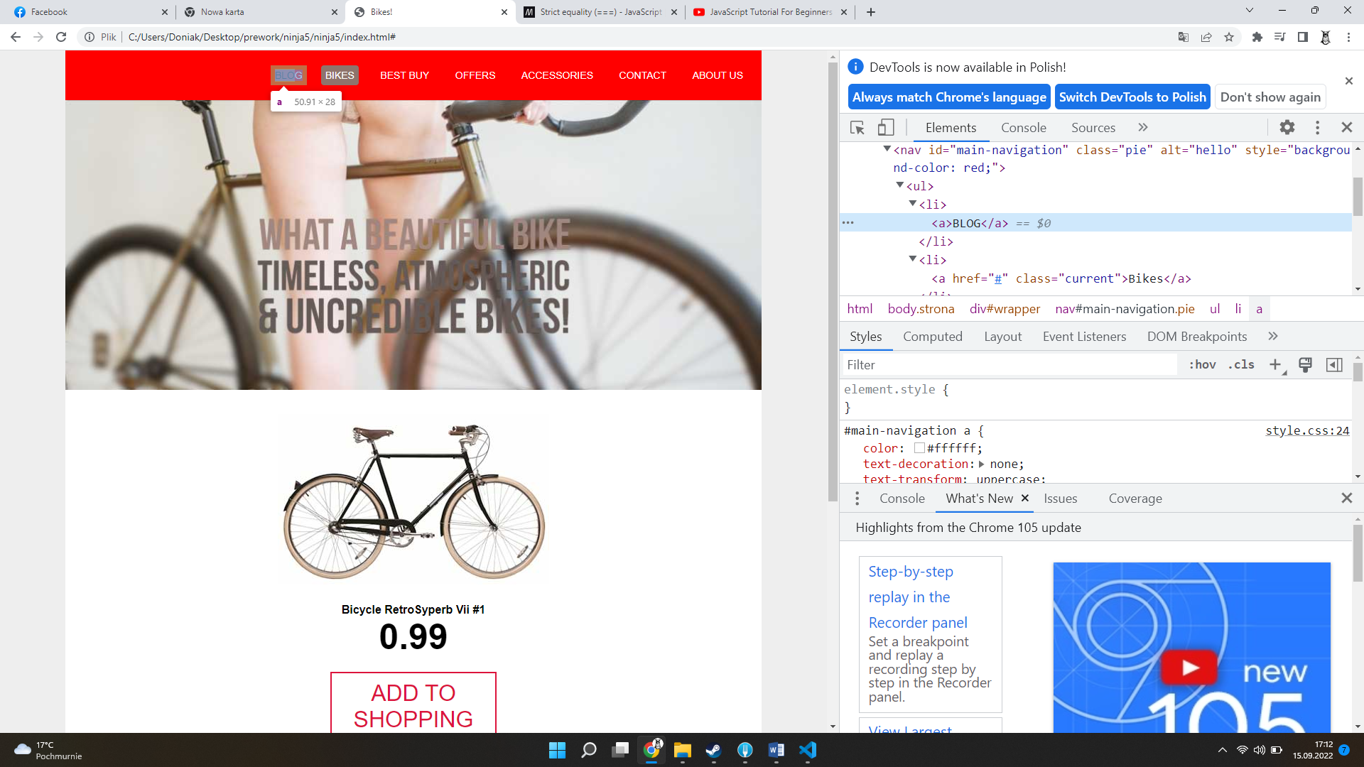

Dodawanie elementu do strony

………………………………………………………….

var parent = document.getElementById("main-navigation").getElementsByTagName("ul")[0];

var child = parent.getElementsByTagName("li")[2];

parent.removeChild(child);

    <nav id="main-navigation" class="nav" alt="hello">

                <ul>

                    <li><a href="#" class="current">Bikes</a></li>

                    <li><a href="#">Best Buy</a></li>

                    <li><a href="#">Offers</a></li>

                    <li><a href="#">Accessories</a></li>

                    <li><a href="#">Contact</a></li>

                    <li><a href="#">About Us</a></li>

                </ul>

            </nav>

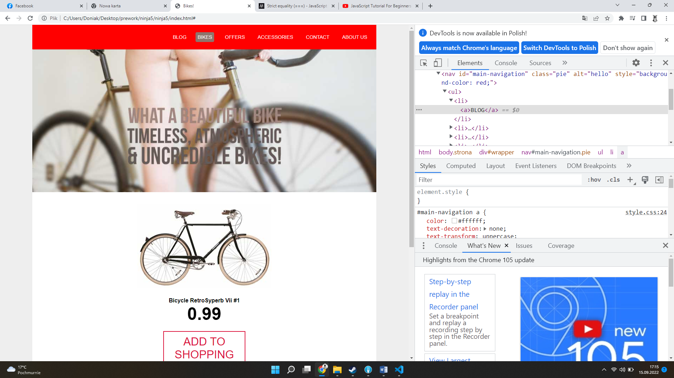

Usuwanie

var leadBanner = document.getElementById("lead-banner");

leadBanner.onclick =function(){

alert("you clicked me");

};

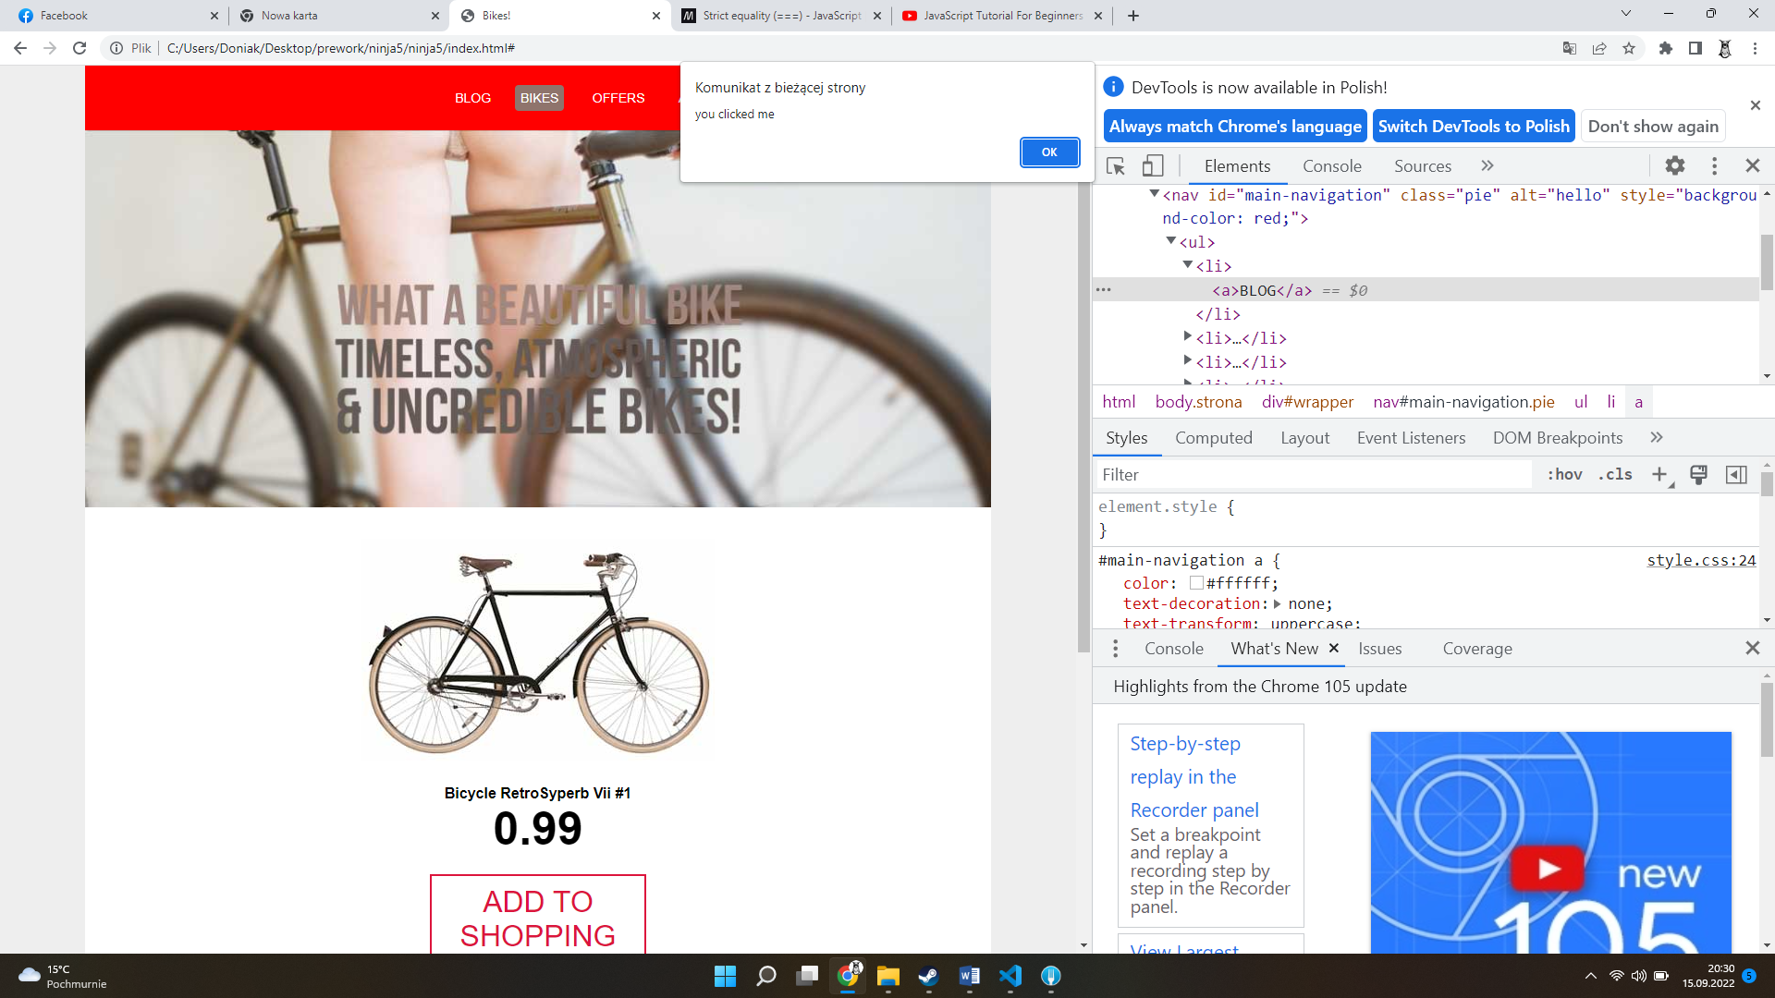

var content = document.getElementById("content");

var button = document.getElementById("button");

button.onclick = function(){

    if(content.className == "open"){

        content.className="";

        button.innerHTML = "Show More";

    } else

    {

        content.className="open";

        button.innerHTML ="Show Less";

    }

}

#content{

width:400px;

background: #fff;

padding: 20px;

padding-top: 0px;

font-size:18px;

color:#444;

margin:0 auto;

max-height:270px;

overflow:hidden;

-webkit-transition: 0.7s;

-moz-transition: max-height 0.7s;

transition: 0.7s;

}

#content.open{

    -webkit-transition: 0.7s;

    -moz-transition: max-height 0.7s;

    transition: 0.7s;

    max-height: 1200px;

}

#guzik{

    margin: 30px 0;

    text-align: center;

    -webkit-transition: 0.7s;

    -moz-transition: max-height 0.7s;

    transition: 0.7s;

    max-height:  300px;

}

#guzik a.button{

    display:block;

    color:crimson;

    text-transform: uppercase;

    font-size: 2em;

    text-decoration:none;

    padding: 10px;

    border: 2px solid;

    width: 210px;

    margin: 20px auto;

}

#guzik a.button:hover{

    color:#ffffff;

    background: #8f746c;

}

     <div id="content">

            Lorem ipsum dolor sit amet consectetur adipisicing elit.

            Dolore accusantium ipsam aut inventore ducimus, corrupti

            praesentium cumque nostrum blanditiis nulla eveniet

            voluptatem magnam optio officiis consequatur delectus,

             voluptatum quod exercitationem.

            <br>

             Lorem ipsum dolor sit amet consectetur adipisicing elit.

            Dolore accusantium ipsam aut inventore ducimus, corrupti

            praesentium cumque nostrum blanditiis nulla eveniet

            voluptatem magnam optio officiis consequatur delectus,

             voluptatum quod exercitationem.

            <br>

             Lorem ipsum dolor sit amet consectetur adipisicing elit.

            Dolore accusantium ipsam aut inventore ducimus, corrupti

            praesentium cumque nostrum blanditiis nulla eveniet

            voluptatem magnam optio officiis consequatur delectus,

             voluptatum quod exercitationem.

            <br>

             Lorem ipsum dolor sit amet consectetur adipisicing elit.

            Dolore accusantium ipsam aut inventore ducimus, corrupti

            praesentium cumque nostrum blanditiis nulla eveniet

            voluptatem magnam optio officiis consequatur delectus,

             voluptatum quod exercitationem.

            </div>

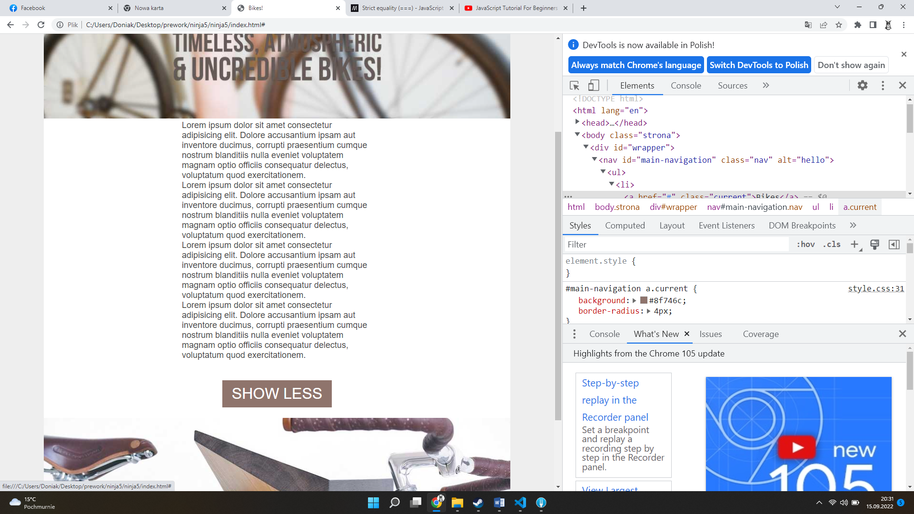

function setUpEvents(){

    var content = document.getElementById("content");

    var button = document.getElementById("button");

    button.onclick = function(){

        if(content.className == "open"){

            content.className="";

            button.innerHTML = "Show More";

        } else

        {

            content.className="open";

            button.innerHTML ="Show Less";

        }

    }

}

window.onload=function(){

    setUpEvents();

};

    <head>

        <meta charset="utf-8" />

        <title>Bikes!</title>

        <link href="style.css" type="text/css" rel="stylesheet">

        <script src="test.js"></script>

    </head>

 setTimeout(button.onclick, 3000);

    var colourChanger = document.getElementById("colour-changer");

    var colours = ["red", "blue", "green", "pink"];

    var counter = 0;

    function changeColour(){

        if(counter >=colours.length){

            counter = 0 ;

        }

        colourChanger.style.background= colours[counter];

        counter++;

    }

    var myTimer = setInterval(changeColour, 300);

    colourChanger.onclick=function(){

        clearInterval(myTimer);

        colourChanger.innerHTML ="timer stopped";

    };

        var fontColourChanger = document.getElementById("content");

        var colours = ["red", "blue", "green", "pink"];

        var counter = 0;

        function fontChangeColour(){

            if(counter >=colours.length){

                counter = 0 ;

            }

            fontColourChanger.style.color= colours[counter];

            counter++;

        }

        var myTimer2 = setInterval(fontChangeColour, 600);

        fontColourChanger.onclick=function(){

            clearInterval(myTimer2);

        };

}

#content{

width:400px;

background: #fff;

padding: 20px;

padding-top: 0px;

font-size:18px;

color:rgb(192, 31, 31);

margin:0 auto;

max-height:270px;

overflow:hidden;

-webkit-transition: 0.7s;

-moz-transition: max-height 0.7s;

transition: 0.7s;

opacity: 0;

}

#content.open{

    -webkit-transition: 0.7s;

    -moz-transition: max-height 0.7s;

    transition: 0.7s;

    max-height: 1200px;

    opacity: 1;

}

#colour-changer{

    width:200px;

    height: 100px;

    margin: 30px auto;

    border: 1px solid #000;

    background: #fff;

    -webkit-transition: 0.7s;

-moz-transition: max-height 0.7s;

transition: 0.7s;

}

Colorchanger

function setUpEvents(){

var myForm = document.forms.myForm;

myForm.name.onfocus = function(){

    myForm.name.style.border = "4px solid pink";

};

myForm.name.onblur = function(){

    myForm.name.style.border = "none";

};

}

window.onload=function(){

    setUpEvents();

};

    <body >

        <form id="form" name="myForm" action="#">

            <label for="name">Name:</label>

            <input type="text" name="name">Name:<br/>

            <label >Hobbies:<br/>

            <input type="checkbox" name="biking" value="biking">Biking<br/>

            <input type="checkbox" name="skiing" value="skiing">skiing<br/>

            <input type="checkbox" name="diving" value="diving">diving<br/>

            <label for="colour">Fav colour:</label>

            <select name="colour">

                <option>Red</option>

                <option>Blue</option>

                <option>Green</option>

            </select>

            <input type="submit" name="submit" value="submit">

        </form>

    </body>

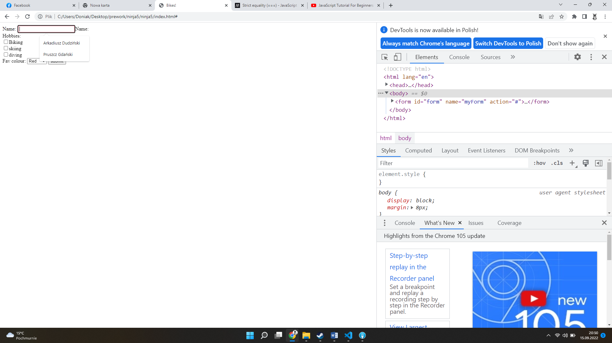

\*\*\*\*\*\*\*\*\*\*\*\*\*\*\*\*\*\*\*\*\*\*\*\*\*\*\*\*\*\*\*\*validacja

var message = document.getElementById("message");  
  
myForm.onsubmit = function(){  
    if(myForm.name.value ==""){  
        message.innerHTML = "please enter a name";  
        return false;  
    }else{  
        message.innerHTML = "";  
        return true;  
    }  
}